**FAKE NEWS DETECTION USING MACHINE LEARNING ALGORITHMS**

K. Shanmukheswara Rao1

GMR INSTITUTE OF TECHNOLOGY, Rajam, India

[20341A0588@gmrit.edu.in](mailto:20341A0588@gmrit.edu.in)1

**ABSTRACT**

In the last several years social media has become a pivotal open communication model for connecting people through several platforms and in this generation, social media networks have become the new trend where people have become much more closer. They are using social networks through online medium to keep in touch and communicate with other people, relatives, and friends. In the past, people used traditional methods to communicate with each other. Nowadays, people are accustomed in using social media networks to express their ideas, beliefs, opinions, and feelings. But now they are using social media networks to read the latest news just in a minute after a bad or good news occurred in the world without fact-checking. This calls for the need to do lots of background checks and verifications. Verifying every news article one after the other by a person is unfeasible and ineffective. This work is meant to study the process of identification of fake news by proposing a system that can reliably classify fake news from the reliable ones. Machine Learning algorithms such as Naive Bayes, Passive Aggressive Classifier, Deep Neural Networks and other classifiers have being used for comparative study in analyzing eight different datasets acquired from various sources. This work also includes the results, analysis and methodologies studied under each model. By comparing all these different algorithms, the best performing algorithm is observed.

**KEYWORDS:** Social Media, Fake News, Natural Language processing, Naive–Bayes, Passive Aggressive Classifier , Deep Neural Network.

# INTRODUCTION

The term fake news refers to those stories which are purposefully designed or created that are indented to promote false occurrence of events and explanations. Throughout history , there are several instances of fake news being spread. Most recent examples include the 2020 U.S. presidential elections where several instances of fake news being circulated are reported throughout the country which includes rigging of all the ballot papers in the polling booths. During COVID-19, there are also reports of fake news related to the origins, cure and treatments regarding the virus. This created a lot of panic among the people which led to anxiety as well. Some of them have also become victims because of these fake news reports. This calls for the need to develop effective ways to detect and prevent fake news effectively. Existing fake news detection algorithms are limited by their computational complexities. The state-of-the-art algorithms also reflect limitations to comply with real world networks. The area of machine learning has grown significantly in the previous decade and it has changed a lot in the last few years. Machine learning is a set of approaches that learn from data or experience that emerged from the study of artificial intelligence. This maturation has centered on reappropriating methodologies and promoting a statistical and probabilistic basis for the approaches in the area of fake news detection. In this study, we have first glanced upon the machine learning classifiers to detect fake news in real world datasets. This is done simply on the pretext to delude the thoughts of individuals. To tackle these problems, machine learning algorithms have been proposed which works on the principle of learning from the previous data or experiences. First, the fake news dataset is taken and data preprocessing is done by making the dataset to go through several phases such as data cleaning , vectorization and feature selection. Then , the machine learning classifiers such as Logistic Regression, Naïve Bayes, SVM etc. are applied to build a predictive model and the further analysis is done by considering different evaluation metrics such as precision, Recall, F1 Score and Accuracy.

**LITERATURE SURVEY**

**[1]Choudhury, D., & Acharjee, T. (2022). A novel approach to fake news detection in social networks using genetic algorithm applying machine learning classifiers. Multimedia Tools and Applications, 1-17.**

* In this study, the author proposes a GA based approach in fake news detection where four different machine learning classifiers are considered as fitness function in proposed algorithm.
* Limited numbers of unique features as well as population size are the major drawbacks.
* Additionally there are limited datasets presented which hinders the performance of the model.
* It has a little better performance than the traditional machine learning applications.

**[2]Fayaz, M., Khan, A., Bilal, M., & Khan, S. U. (2022). Machine learning for fake news classification with optimal feature selection. *Soft Computing*, 1-9**.

* In this study, a mechanism has been taken on fact-checking rumors and statements particularly those that get thousands of views and likes before being debunked and refuted by expert sources.
* Ensemble Models were not incorporated which would increase the overall accuracy score.
* The experimental results show that proposed model outperformed all other classifiers in terms of better classification accuracy.

**[3]Zervopoulos, A., Alvanou, A. G., Bezas, K., Papamichail, A., Maragoudakis, M., & Kermanidis, K. (2022). Deep learning for fake news detection on Twitter regarding the 2019 Hong Kong protests. *Neural Computing and Applications*, *34*(2), 969-982**

* In this paper, previous work regarding the classification of fake news concerning the Hong Kong protests with the use of traditional machine learning (ML) algorithms is extended.
* Limited Dataset is the main drawback in this paper.
* The results seem to be very promising, achieving as high as 99.3% F1 Score, significantly outperforming the more traditional approaches used in previous work, utilizing the state-of the-art XLM-RoBERTa model.

**[4]Braşoveanu, A. M., & Andonie, R. (2021). Integrating machine learning techniques in semantic fake news detection. *Neural Processing Letters*, *53*(5), 3055-3072**

* This study discusses a semantic fake news detection method built around relational features like sentiment, entities or facts extracted directly from text.
* Lacks of additional dataset along with recently developed R-GCN are the major drawbacks.
* Easy to implement and process the dataset are the main advantages by studying this paper.

**[5]Mandical, R. R., Mamatha, N., Shivakumar, N., Monica, R., & Krishna, A. N. (2020, July). Identification of fake news using machine learning. In 2020 IEEE International Conference on Electronics, Computing and Communication Technologies (CONECCT) (pp. 1-6). IEEE.**

* In this paper, the author attempts to expedite the process of identification of fake news by proposing a system that can reliably classify fake news.
* Limitation of implementing better models. Along with that, word embedding’s such as word2Vec and GloVe could be used.
* Better Performance, accuracy and F1 score are the major advantages.

**METHODOLOGY/RECENT TECHNOLOGY**

**METHODOLOGY 1:**

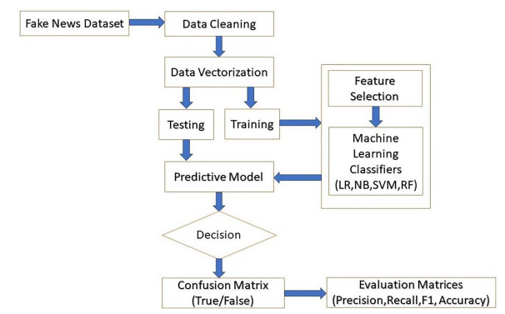

**Fig 1: Training and Testing the Dataset**

* **Fake news dataset:** A raw dataset of fake news is taken.
* **Data Cleaning:** Here the data which is incorrect, incomplete, irrelevant, duplicated, or improperly formatted is modified or removed.
* **Data Vectorization**: There are mainly four steps involved in vectorization of the data such as splitting of the dataset in training and testing sets, taking care of missing values, taking care of categorical features and normalization of dataset. Using of scikit-learn package in python, pre-processing is efficiently done for the input data.
* **Feature Selection**: To select the categorical features, TF-IDF is used since TF computes the frequency of a term appears in a document.
* **Machine Learning Classifiers**: Naïve Bayes, SVM, Random Forest, Logistic Regression and others are some of the classifiers used to build a predictive model.
* **Predictive Model**: In this stage, training dataset is fitted with the ML classifiers and the testing dataset is run onto it to check the accuracy of the model.
* **Confusion Matrix**:

True Positive (TP): Predicted false news are really defined as false news

True Negative (TN): Predicted real news are really defined as true news

False Negative (FN): Predicted real news are really defined as false news

**METHODOLOGY 2: Naïve Bayes**

* The formula for Naïve Bayes classifier is:

P (A|B) = **(**P (A).P (B|A)**)/(** P (B)**) …(1)**

where A and B are two conditions. Naïve Bayes classifier takes each characteristic as a condition and classifies the samples with the highest probability of occurrence.

* The NB classifier in a model will count the number of times a word occurs in the ‘Statement’ in the LIAR dataset, ‘description’ in the Fake Job Posting dataset, and ‘text’ in the Fake News dataset, when the news is given to be fake. Then it converts it to a probability and calculates the chance of a ‘Statement’ being fake against a ‘Statement’ being true. Some popular examples of Naïve Bayes Algorithm are **spam filtration, Sentimental analysis, and classifying articles**.
* It is called Naïve because it assumes that the occurrence of a certain feature is independent of the occurrence of other features.  It is called Bayes because it depends on the principle of  Bayes Theorem. And thus the name Naïve Bayes.

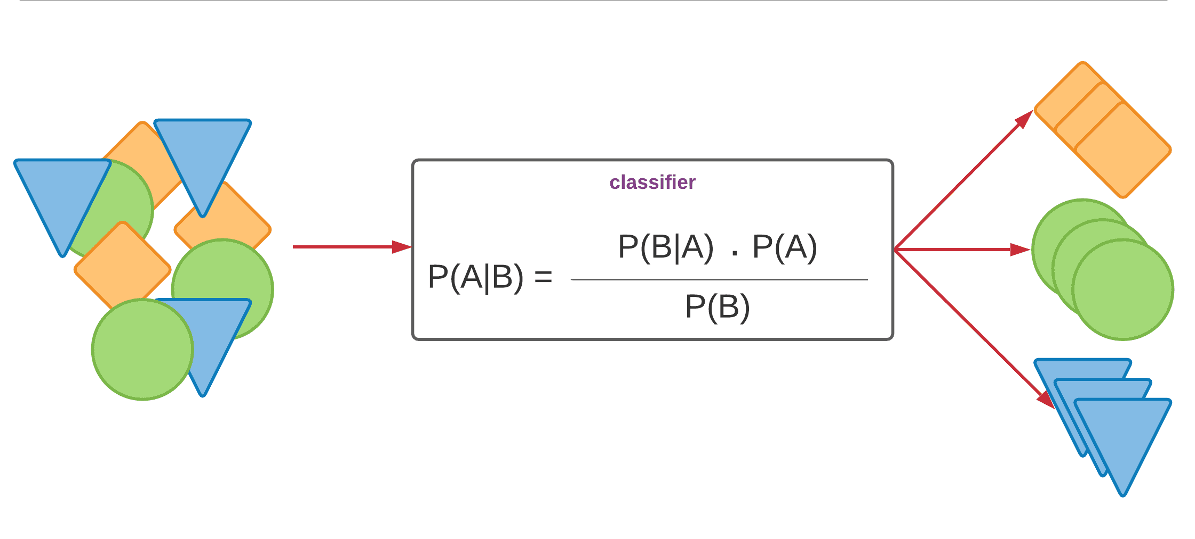

**Fig 2: Naïve Bayes Classifier**

**METHODOLOGY 3: Random Forest**

It works based on the mean squared error(MSE):

$$MSE =\frac{1}{N}\sum_{i=1}^{N}{{(f_{i}-y_{i})}^{2} …(2) }$$

Where,

N = Number of data points

fi = Value returned by the model

yi = Actual value for data point i

The random forest classifier is an ensemble system that operates and thus increases the accuracy of a multitude of decision trees. In order to detect fake news from the testing data, the parameters such as max depth, min samples split, n estimators, and random state are changed; where max depth is the maximum depth of a decision tree, min samples split is the minimum amount of samples to split an internal node, and N estimators is the number of random forest decision trees.

**Random Forest is a classifier that contains a number of decision trees on various subsets of the given dataset and takes the average to improve the predictive accuracy of that dataset.**Instead of relying on one decision tree, the random forest takes the prediction from each tree and based on the majority votes of predictions, and it predicts the final output. Increase in the number of trees will automatically increase the accuracy of the model. There are a few assumptions before using random forest classifier or algorithm. They are:

* There should be actual values related to the feature variable in the dataset so that the algorithm can accurately predict the results.
* There should be little to no correlations among the predicted results of all the trees. In other words, no two trees should predict similar kind of results.

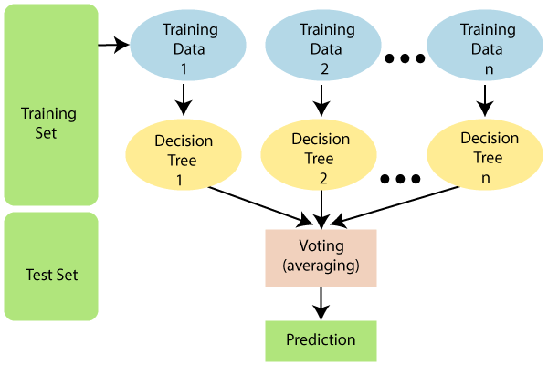

**Fig 3: Random Forest Classifier**

**METHODOLOGY 4: SVM**

SVM is a supervised algorithm for machine learning that can be used for purposes of both classification and regression. In classification issues, SVMs are often used. The idea of finding a hyperplane that best divides a dataset into two groups is the foundation of SVMs. Support vectors are the data points closest to the hyperplane and the data set points would change the direction of the dividing hyperplane if removed. The distance from either set between the hyperplane and the nearest data point is known as the margin. In this study, the goal is to choose a hyperplane with the greatest possible margin within the training set between the hyperplane and any point which provide a higher probability of correctly classifying the news as, for example ‘Statement’ in the LIAR dataset as ‘true’ or ‘fake’. We have used Radial Basis Function kernel in our model. SVM algorithm can be used for Face detection, image classification, text categorization, etc.

* There can be multiple lines/decision boundaries to segregate the classes in n-dimensional space, but we need to find out the best decision boundary that helps to classify the data points. This best boundary is known as the **hyperplane** of SVM.
* The data points or vectors that are the closest to the hyperplane and which affect the position of the hyperplane are termed as **Support Vector**.

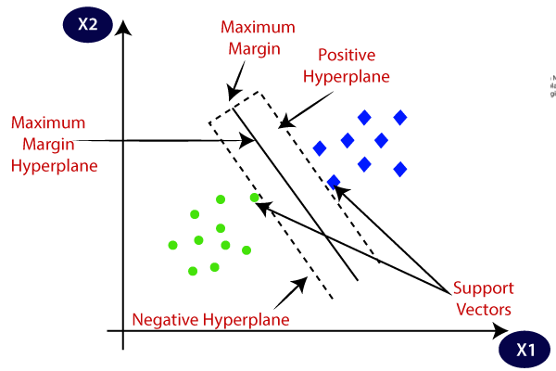

**Fig 4: Support Vector Machine (SVM) Classifier**

**METHODOLOGY 5: Logistic Regression**

A classification algorithm used to assign observations to a discrete group of groups is logistic regression. This classifier adjusts its yield using the measured sigmoid ability to restore a probability which is mapped to at least two different groups (‘true’ or ‘fake’) in case of fake news detection. A linear function f (x) = b0 + b1x1 + ··· + brxr, also termed as logit. The variables b0, b1, ..., br are the estimators of the regression coefficients, also known as predicted weights.

* Logistic regression predicts the output of a categorical dependent variable. Therefore, the outcome must be a categorical or discrete value. It can be either Yes or No, 0 or 1, true or False, etc. but instead of giving the exact value as 0 and 1, it gives the probabilistic values which lie between 0 and 1.
* Logistic Regression is much similar to the Linear Regression except that how they are used. Linear Regression is used for solving Regression problems, whereas Logistic regression is used for solving the classification problems.

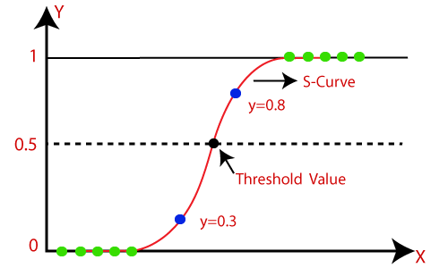

**Fig 5: Sigmoid Function**

**Sigmoid Function:**

* The sigmoid function is a mathematical function used to map the predicted values to probabilities.
* It maps any real value into another value within a range of 0 and 1.
* The value of the logistic regression must be between 0 and 1, which cannot go beyond this limit, so it forms a curve like the "S" form. The S-form curve is called the Sigmoid function or the logistic function.
* In logistic regression, we use the concept of the threshold value, which defines the probability of either 0 or 1. Such as values above the threshold value tends to 1, and a value below the threshold values tends to 0.

**RESULTS & DISCUSSION**

After analyzing the fake news dataset through various performance metrics, we have the following results:

|  |  |  |  |  |  |
| --- | --- | --- | --- | --- | --- |
| **S. No** | **Classifier** | **Precision** | **Recall** | **F1 Score** | **Accuracy** |
| 1. | Naive Bayes | 0.88 | 0.96 | 0.91 | 0.90 |
| 2. | SVM | 0.96 | 0.97 | 0.97 | 0.96 |
| 3. | Logistic Regression | 0.95 | 0.96 | 0.96 | 0.95 |
| 4. | Random Forest | 0.94 | 0.97 | 0.95 | 0.95 |

* From the obtained results , it is very clear that SVM performed better in precision followed by Logistic Regression, Random Forest and Naïve Bayes classifier.
* Both SVM and Random Forest have the same recall (97%) followed by Logistic Regression and Naïve Bayes which have a recall of 96%.
* Similarly, SVM performed better in F1 score(97%) followed by Logistic Regression, Random Forest and Naïve Bayes.
* SVM had a better accuracy of 96% followed by other classifiers.

**CONCLUSION**

In this study, we have done a comparative study of various Machine learning algorithms to detect fake news by considering a fake news dataset. In this analysis, we examined the performance of all the major machine learning and deep learning algorithms as well. These include convoluted neural networks, other major classifiers such as Naïve Bayes, Support Vector Machine(SVM) , Logistic Regression and Random Forest. It is also observed that some of the algorithms were enhanced using hyperparameter tuning. In some cases, new models were developed by either using the above models or new ones which are further enhanced. After the analysis, it is concluded that SVM classifier outshines the other Machine Learning classifiers i.e., Naïve Bayes, Logistic Regression and Random Forest. The SVM algorithm has exceeded in all the fronts such as Precision, Recall, Accuracy, F1 score. To continue, we can increase the number of features to improve the performance of the models. Along with that, the size of the dataset needs to be enhanced further to obtain better and accurate results in the future.

**REFERENCES**

1. Choudhury, D., & Acharjee, T. (2022). A novel approach to fake news detection in social networks using genetic algorithm applying machine learning classifiers. *Multimedia Tools and Applications*, 1-17.
2. Fayaz, M., Khan, A., Bilal, M., & Khan, S. U. (2022). Machine learning for fake news classification with optimal feature selection. *Soft Computing*, 1-9.
3. Zervopoulos, A., Alvanou, A. G., Bezas, K., Papamichail, A., Maragoudakis, M., & Kermanidis, K. (2022). Deep learning for fake news detection on Twitter regarding the 2019 Hong Kong protests. *Neural Computing and Applications*, *34*(2), 969-982.
4. Braşoveanu, A. M., & Andonie, R. (2021). Integrating machine learning techniques in semantic fake news detection. *Neural Processing Letters*, *53*(5), 3055-3072
5. Mandical, R. R., Mamatha, N., Shivakumar, N., Monica, R., & Krishna, A. N. (2020, July). Identification of fake news using machine learning. In 2020 IEEE International Conference on Electronics, Computing and Communication Technologies (CONECCT) (pp. 1-6). IEEE
6. Cartwright, B., Frank, R., Weir, G., & Padda, K. (2022). Detecting and responding to hostile disinformation activities on social media using machine learning and deep neural networks. Neural Computing and Applications, 1-23.
7. Habib, A., Asghar, M. Z., Khan, A., Habib, A., & Khan, A. (2019). False information detection in online content and its role in decision making: a systematic literature review. Social Network Analysis and Mining, 9(1), 1-20.
8. Mahabub, A. (2020). A robust technique of fake news detection using Ensemble Voting Classifier and comparison with other classifiers. SN Applied Sciences, 2(4), 1-9.
9. Li, X., Lu, P., Hu, L., Wang, X., & Lu, L. (2021). A novel self-learning semi-supervised deep learning network to detect fake news on social media. Multimedia Tools and Applications, 1-9.

[10] Sadeghi, F., Bidgoly, A. J., & Amirkhani, H. (2022). Fake news detection on social media using a natural language inference approach. Multimedia Tools and Applications, 1-21.

[11] Kaliyar, R. K., Goswami, A., & Narang, P. (2021). EchoFakeD: improving fake news detection in social media with an efficient deep neural network. Neural computing and applications, 33(14), 8597-8613.

[12] Ma, K., Tang, C., Zhang, W., Cui, B., Ji, K., Chen, Z., & Abraham, A. (2022). DC-CNN: Dual-channel Convolutional Neural Networks with attention-pooling for fake news detection. Applied Intelligence, 1-16.

[13] Ahmed, S., Hinkelmann, K., & Corradini, F. (2022). Development of fake news model using machine learning through natural language processing. arXiv preprint arXiv:2201.07489.

[14] Wani, A., Joshi, I., Khandve, S., Wagh, V., & Joshi, R. (2021, February). Evaluating deep learning approaches for covid19 fake news detection. In International Workshop on​ Combating On​ line Ho​ st​ ile Posts in​ Regional Languages dur​ ing Emerge​ ncy Si​ tuation (pp. 153-163). Springer, Cham.

[15]Vijayaraghavan, S., Wang, Y., Guo, Z., Voong, J., Xu, W., Nasseri, A., ... & Wadhwa, E. (2020). Fake news detection with different models. arXiv preprint arXiv:2003.04978.